Concept of linked project

Click on your codetest job



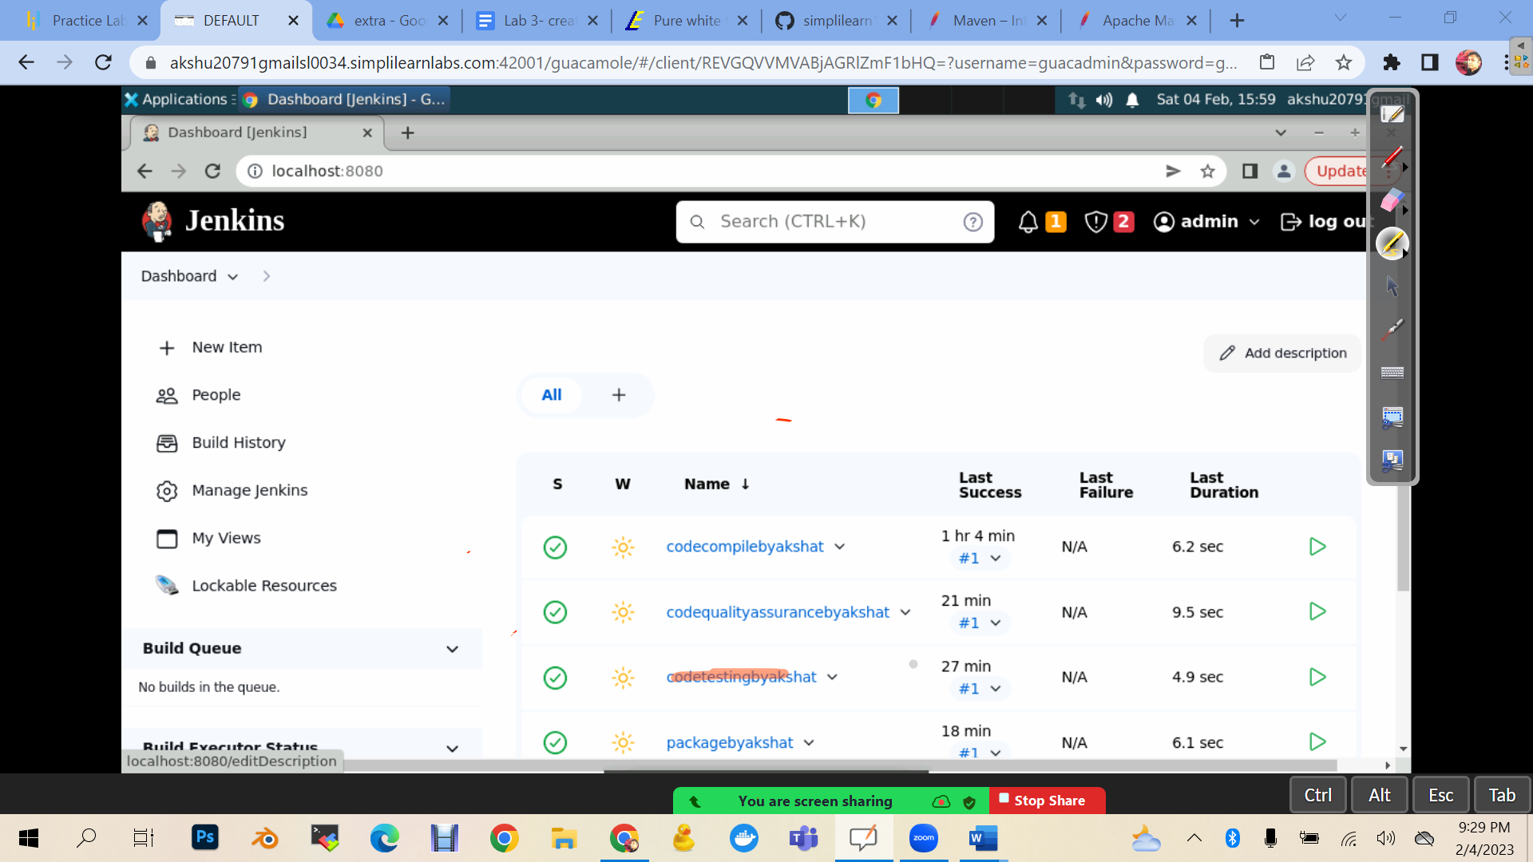



Click on configure

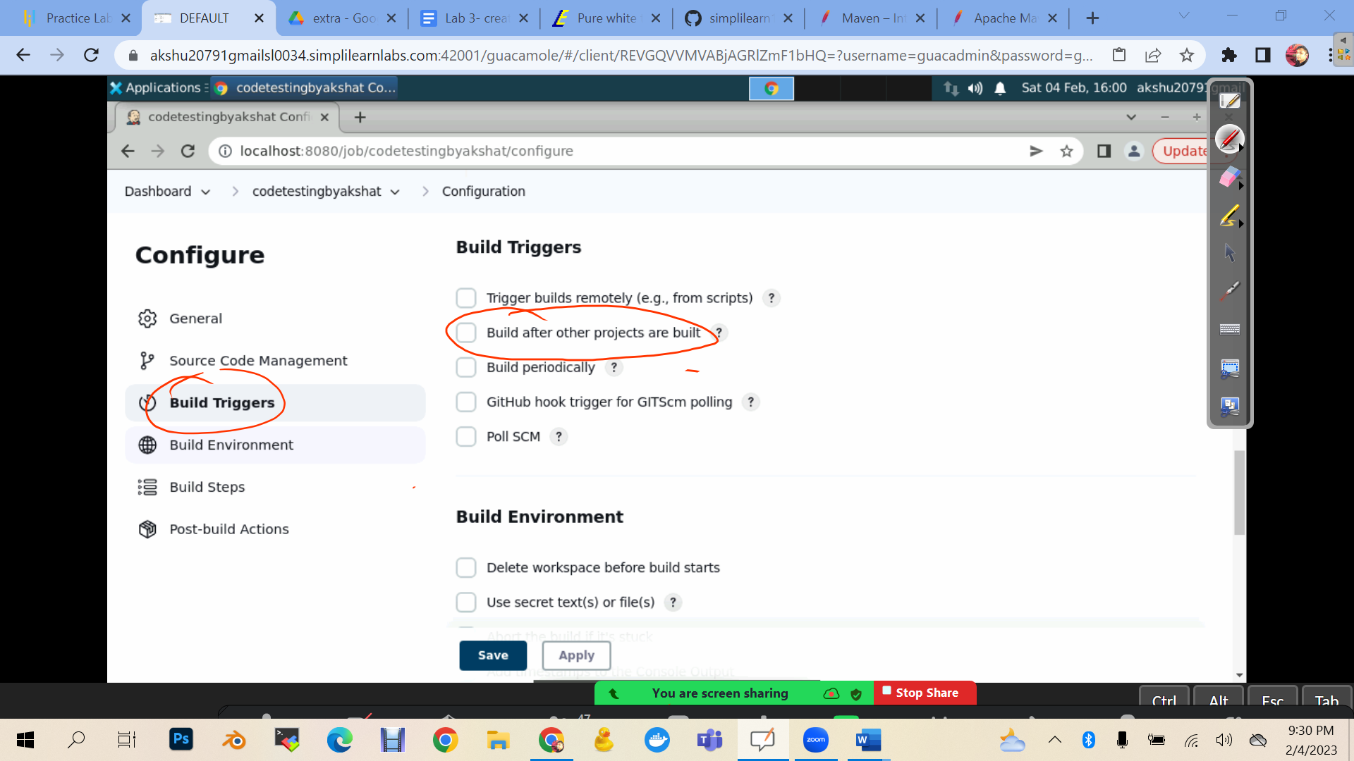

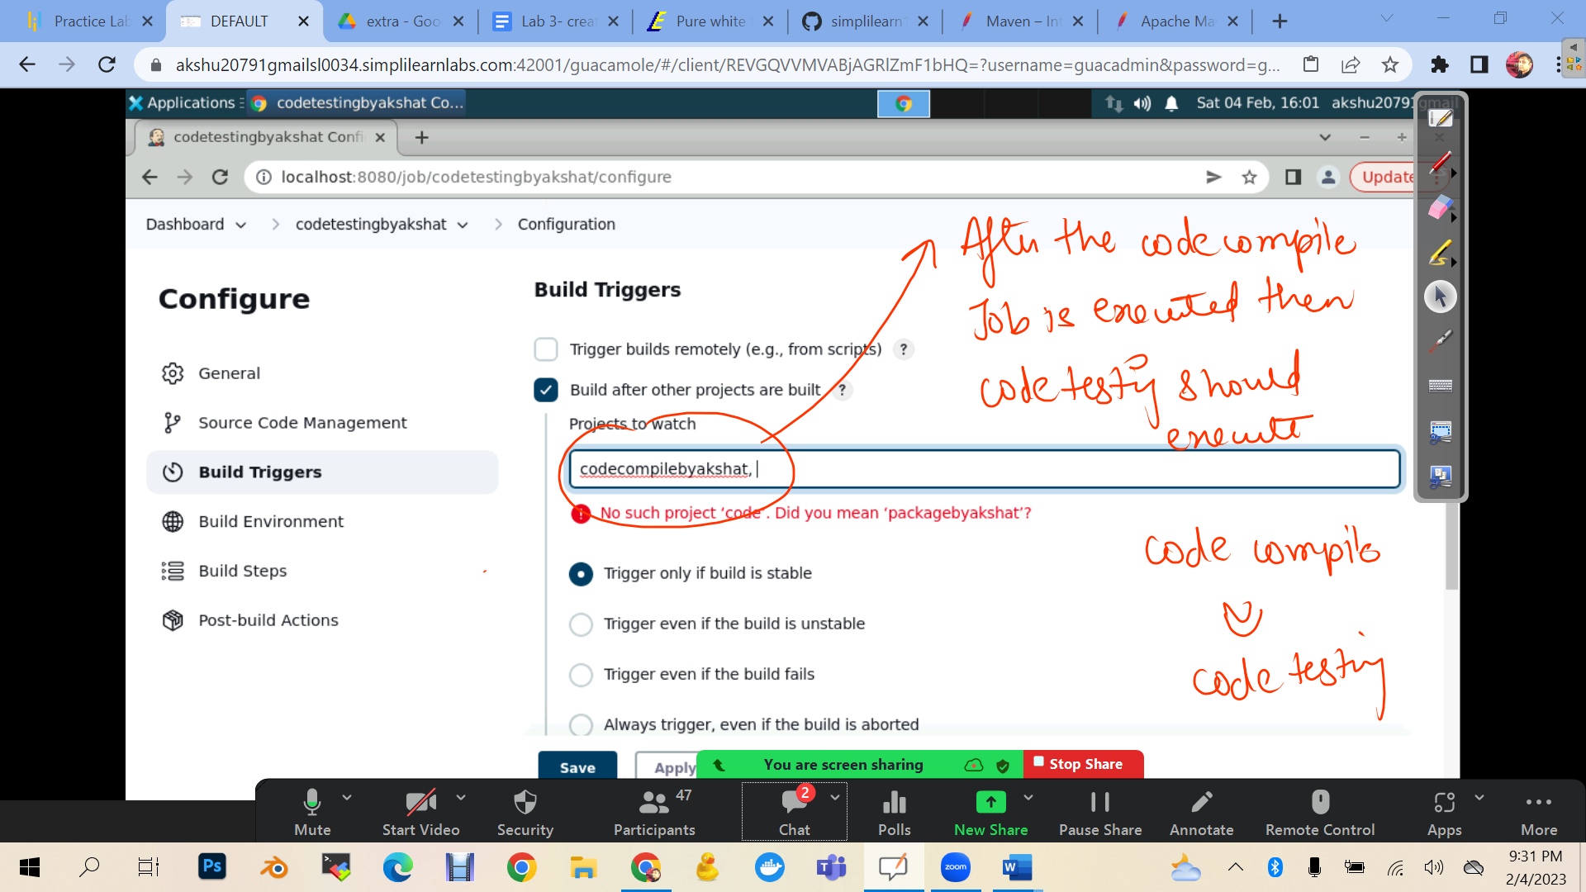

Save

Go to code code qa

Configure

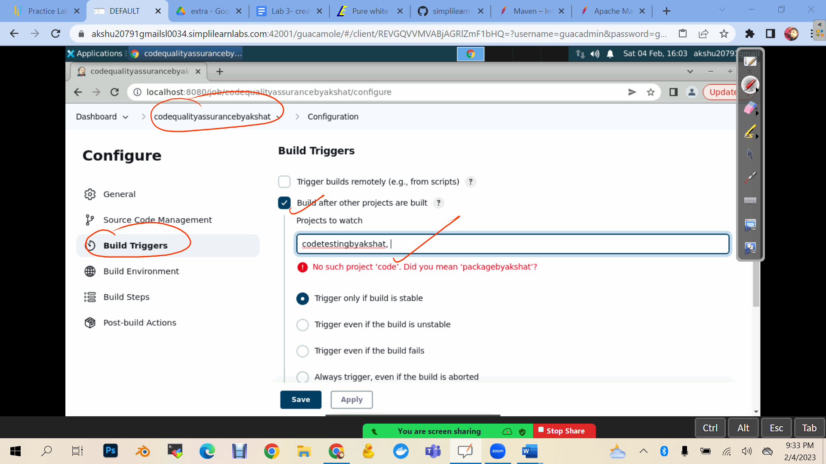

Save

Go to package job

Configure

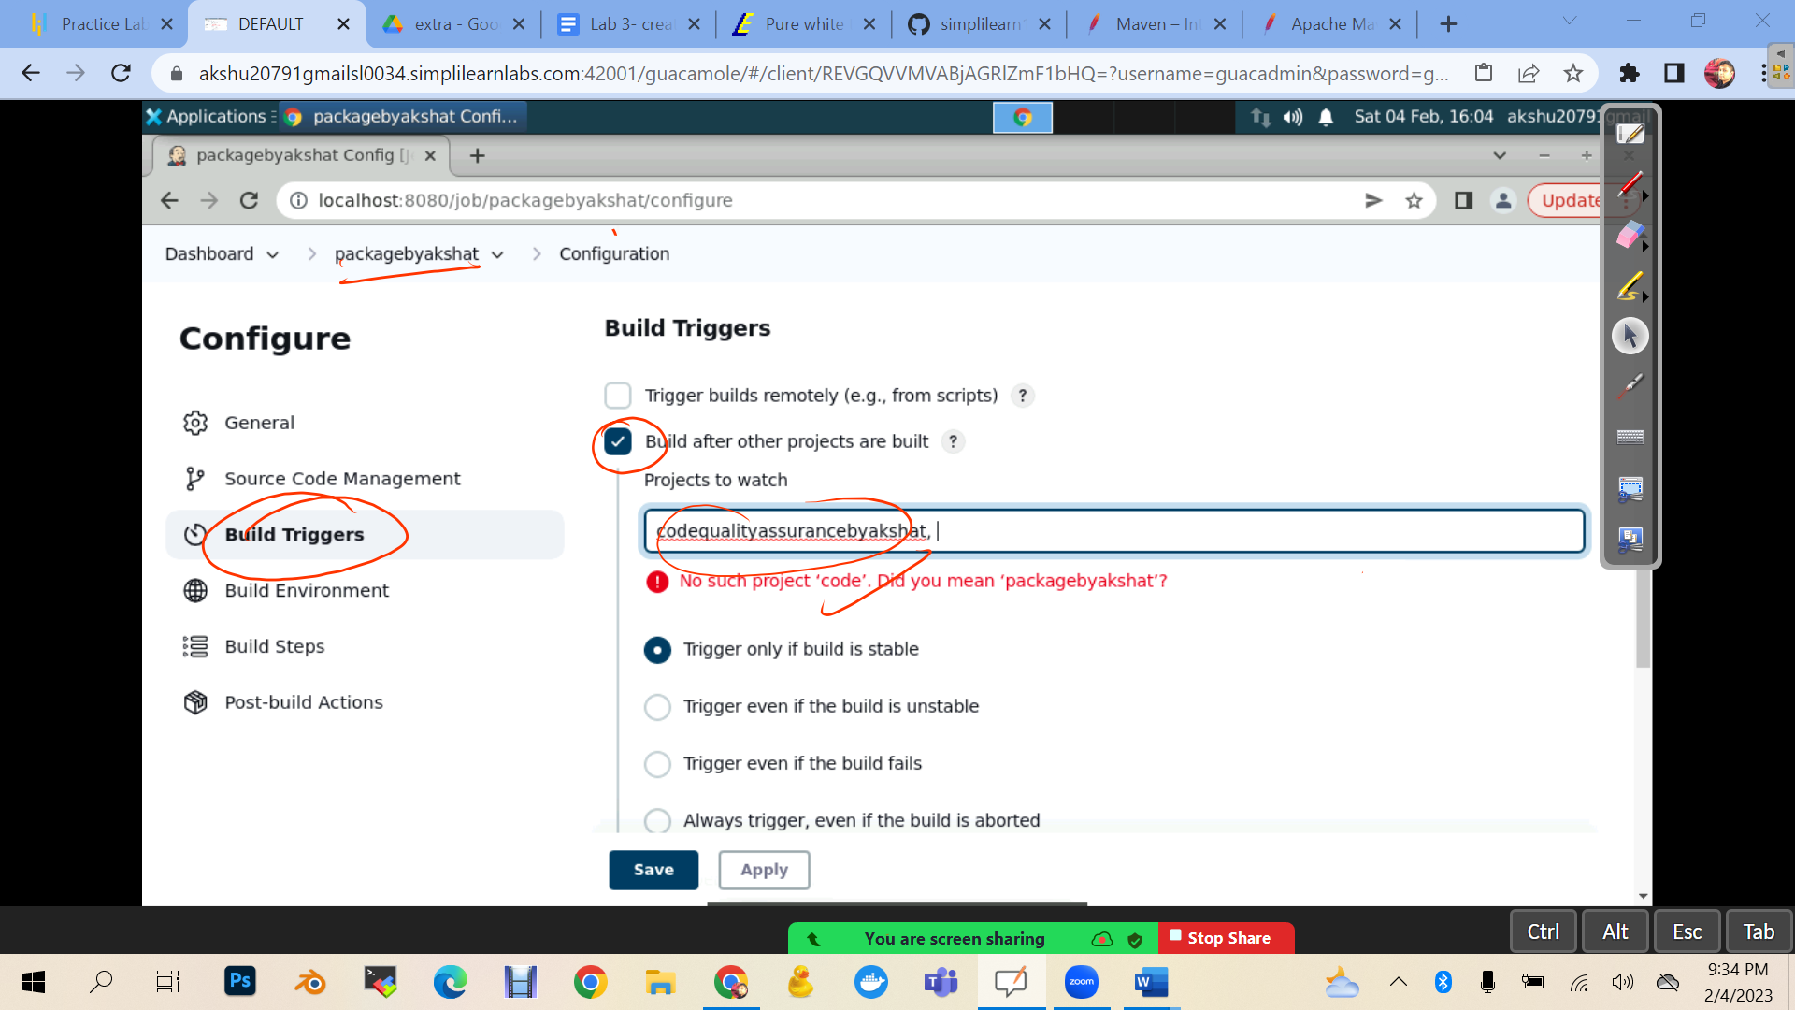

Now if u execute the code compile u will see that code test will also execute after that code qa will also execute and then package will also execute….